Team assignment 6: Productivity.
Version 0.3.0 created on 20th Mar 2012. By SON dang.
Note: Read by team member only.

- Introduction.
This document provides information support reader to understand why and how to define productivity of organization (team).
Outputs (products) of team assignment are used to measure are document, tasks and score.
……
- Priority of tasks and productivity using task priority.
For individual.
Each assignment, we divide them into tasks. To evaluate size of work we base on completed tasks in before assignments. But problem is all tasks in assignment are not the same so define priority for each task is necessary.
Evaluate spent effort for each task of each assignment will help us to define productivity of team.
The following table will describe priority and point of each task in all team assignments. (Statistics base on history data of team).
Assignment | Task | Point | Role
1 | Make roles and responsibility | 1 | Tin
1 | Make process | 1 | Son
1 | Schedule for 15 weeks | 1 | Tam
1 | Review & integrate | 1 | Huyen
1 | Review schedule for 15 weeks | 1 | Van
2 | Make assignment | 3 | All
2 | Integrate | 1 | Huyen
3 | Make assignment | 3 | All
3 | Integrate | 1 | Son
4 | Make assignment | 3 | All
4 | Integrate | 1 | Tam
5 | Make WBS | 1 | All
5 | Schedule | 3 | All
5 | Network diagram | 1 | All
5 | Integrate | 1 | Tin
6 | Individual productivity | 2 | Tin
6 | Team productivity | 2 | Son
6 | How to improve productivity | 2 | Tam
6 | Integrate | 1 | Huyen

How can we know priority of these tasks? – We base on the complexity of this task. Example: with assignments that cannot be divided into tasks, the complexity of it is HIGH, so its point is 3. And if can be divided into task, each this task just has 1 point. But in some special task, we must use brain storming method to make decision how many point for each task.
Example for using (metrics): in assignment 1, Tin and Son do 2 tasks have same priority. Tin spent 2 hours for his task; Son spent 4 hours for his task. We get Tin’s (or Son) score multiply with his task priority point and divide into his spent hour.
TIN: Score is 475. Productivity = 475*1/2
SON: Score is 950. Productivity = 950*1/4
2 results are same. So their performance is the same.
Metric: Score of member * priority point of his (or her) task / spent hour.
For team.
Like metric for individual.
Metric: Score of team * total priority point of this assignment / total spent hours of all members.

So, how do we know that productivity is good or bad, what is the standard?
---- Too difficult, I don’t know, need help.
- Productivity on team view using score only.
Productivity is a measurement; help developers measure their effectiveness of work. The simplest way to define productivity is measure OUTPUT/INPUT. In software, this is SIZE/EFFORT. But define exact size or effort in software is a hard work.
In this assignment, we have to define what is the size and effort of our team work.
The size of work can be measured by output of it. We assume our output (product) is score of this assignment. The higher score, the bigger size.
The effort of work can be measured by number of spent hour in assignment of all members.
I will describe how I can give my idea about productivity in following picture. Using GQM approach.
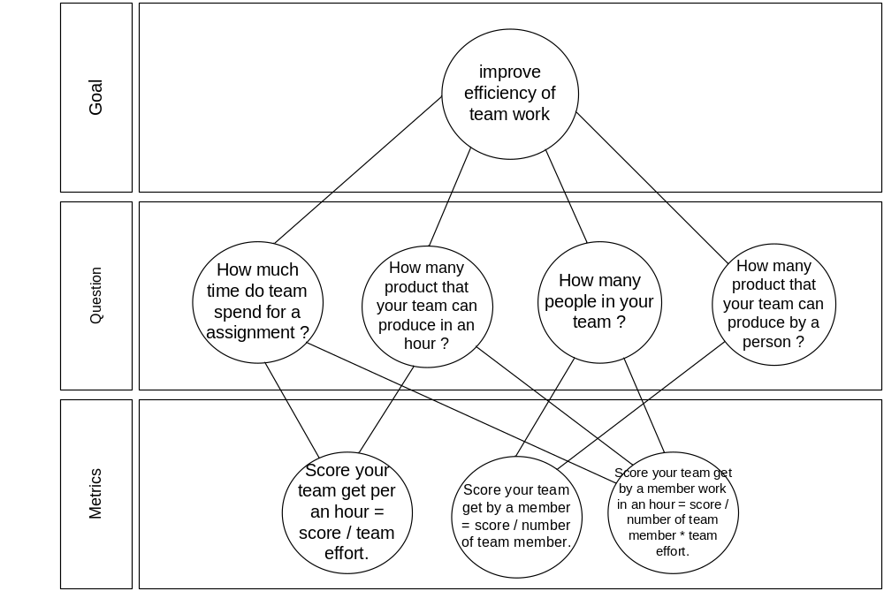
With above set of metrics we can use to measure our team effectiveness, and bring our measurement results compare to the others team.
..

